EENG 385 - Electronic Devices and Circuits

Frequency Domain: Active Filters

How To: Design a Filter

**How To: Design a Filter**

While we could do a bunch of math to design filters, in truth practicing engineers use design tools to help them accomplish their goals. Towards this end, we will investigate how to use the Analog Devices, Analog Filter Design (<https://tools.analog.com/en/filterwizard/>) tool to design some filters. You will simulate them, build them and the test them. Let’s get started.

Start by opening a web page for the filter wizard tool. Let’s start by designing a Low Pass filter. The Specifications pages allows you to define the performance of your filter. There are three main parameters that you must specify:

Passband:

* Gain The gain of the `filter in the passband is called Gain

* dB at Hz This defines the corner frequency

Stopband:

* dB at Hz The maximum gain of the filter at this frequency in the stopband

Filter response

Slider that defines the shape of the constellation of poles which also

determines the order of the filter.

Configure your low pass filter as follows:

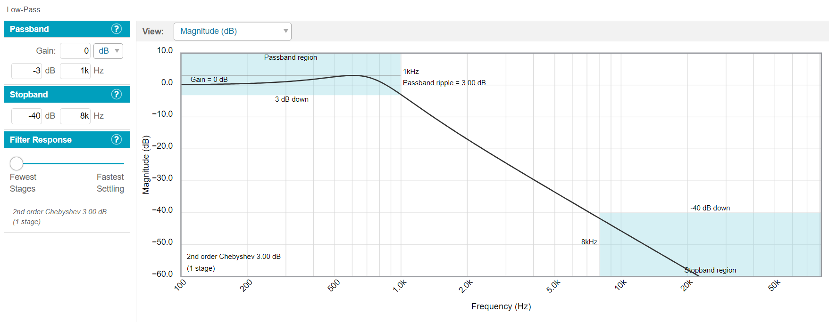

Figure 1: A low pass filter design in the Analog Devices tool.

Next click on the Components tab to progress in the design and change the -Vs value to 0V. Note if you do not like the component values chosen by the design Wizard try clicking on the “I want to choose” radio button in the Components area and then use the RC sizing slider to get capacitors that are on whole decade. For example, 10nF, 100nF, 1uF, 10uF etc. These are called E1 series values. I’d suggest walking over to the components bins and looking at what values we have available and then using this as your preferred capacitor value. We do NOT have 3.9nF capacitors nor 390pF capacitors, shown in the design below and making them by arranging components in parallel will be a huge pain.

Next click on the Tolerances tab and configure your filter to use E6 component values. Note this is a bad design because it uses non-decade capacitors (220pf and 2.2nF). You should go back to the previous step and use the RC slider to get decade capacitors.

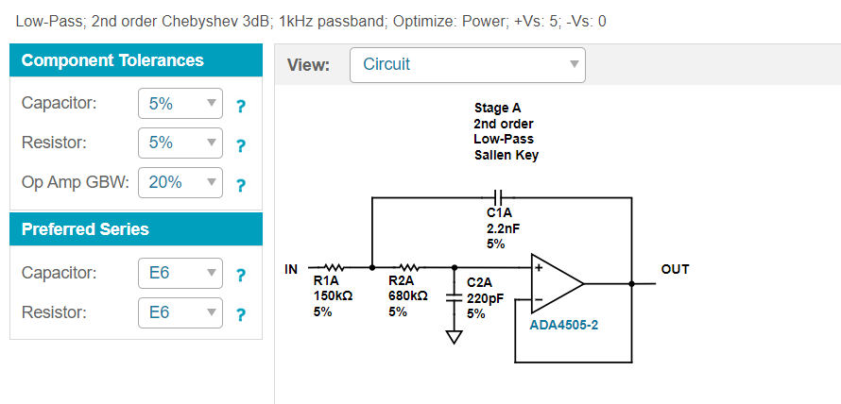

Figure 2: The component selection step of the filter design wizard.

Try clicking on the View pulldown and select Magnitude (dB) to see how variation in the component values effects the frequency response of the filter.

Congrats, you have designed your filter. Now it’s time to simulate and then assemble a working filter.